**Lab Task 1: Design an IP Address Scheme** [**site24x7**](https://www.site24x7.com/tools/ipv4-subnetcalculator.html)

1. The network 172.16.10.0/16 was divided into seven subnets, as outlined below:

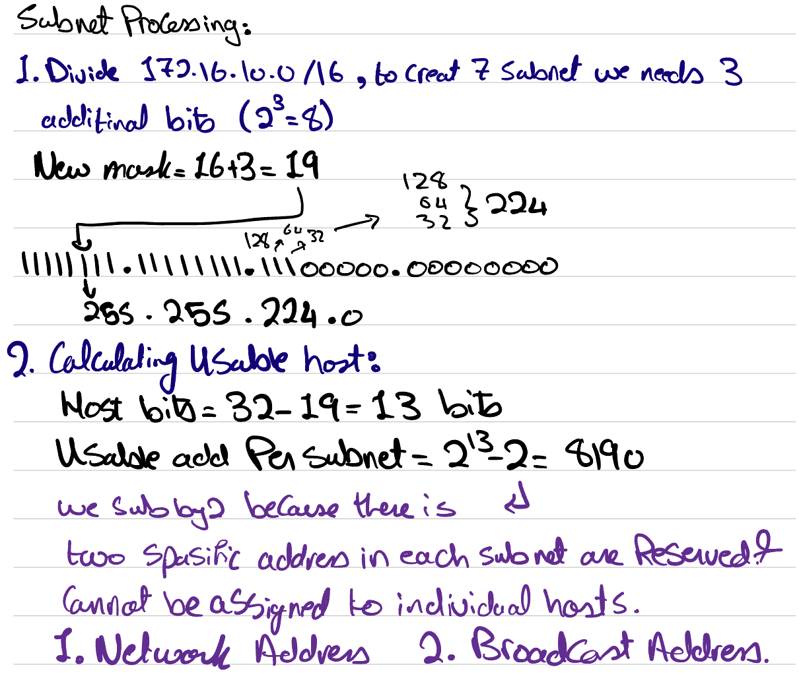

1. The value of the new subnet mask is 255.255.224.0
2. 2^19=8190 usable hosts exist per subnet.

|  |  |  |  |  |
| --- | --- | --- | --- | --- |
| **Subnet ID** | **Network address** | **Host Address Range** | **Broadcast Address** | **Subnet mask** |
| 1 | 172.16.0.0 | 172.16.0.1 - 172.16.31.254 | 172.16.31.255 | 255.255.224.0 |
| 2 | 172.16.32.0 | 172.16.32.1 - 172.16.63.254 | 172.16.63.255 | 255.255.224.0 |
| 3 | 172.16.64.0 | 172.16.64.1 - 172.16.95.254 | 172.16.95.255 | 255.255.224.0 |
| 4 | 172.16.96.0 | 172.16.96.1 - 172.16.127.254 | 172.16.127.255 | 255.255.224.0 |
| 5 | 172.16.128.0 | 172.16.128.1 - 172.16.159.254 | 172.16.159.255 | 255.255.224.0 |
| 6 | 172.16.160.0 | 172.16.160.1 - 172.16.191.254 | 172.16.191.255 | 255.255.224.0 |
| 7 | 172.16.192.0 | 172.16.192.1 - 172.16.223.254 | 172.16.223.255 | 255.255.224.0 |

**Lab Task 2: Implement VLANs and Trunk**  
*(Listed commands were executed on S1-Office1 and S2-Office1.)*

1. en  
   conf t  
   vlan 10  
   name Management  
   exit  
   vlan 20  
   name Marketing  
   exit  
   vlan 30  
   name Accounting  
   exit  
   vlan 100  
   name Native  
   exit
2. int range fa0/1-10  
   switchport mode access  
   switchport access vlan 10  
   exit  
   int range fa0/11-20  
   switchport mode access  
   switchport access vlan 20  
   exit  
   int range fa0/21-24  
   switchport mode access  
   switchport access vlan 30  
   exit

Make sure that you connect pc’s to switch in the correct Range

1. * ***On S1-Office1:***

int gi0/2  
switchport mode trunk  
switchport trunk native vlan 100  
exit  
show vlan brief  
show int trunk

* + ***On S2-Office1:***

int gi0/1  
switchport mode trunk  
switchport trunk native vlan 100  
exit  
show vlan brief   
show int trunk

1. Interface gig0/1  
   switchport nonegotiate  
   exit  
   wr

S1-Office1# show vlan brief S2-Office1# show vlan brief

S1-Office1#show int trunk S2-Office1#show int trunk

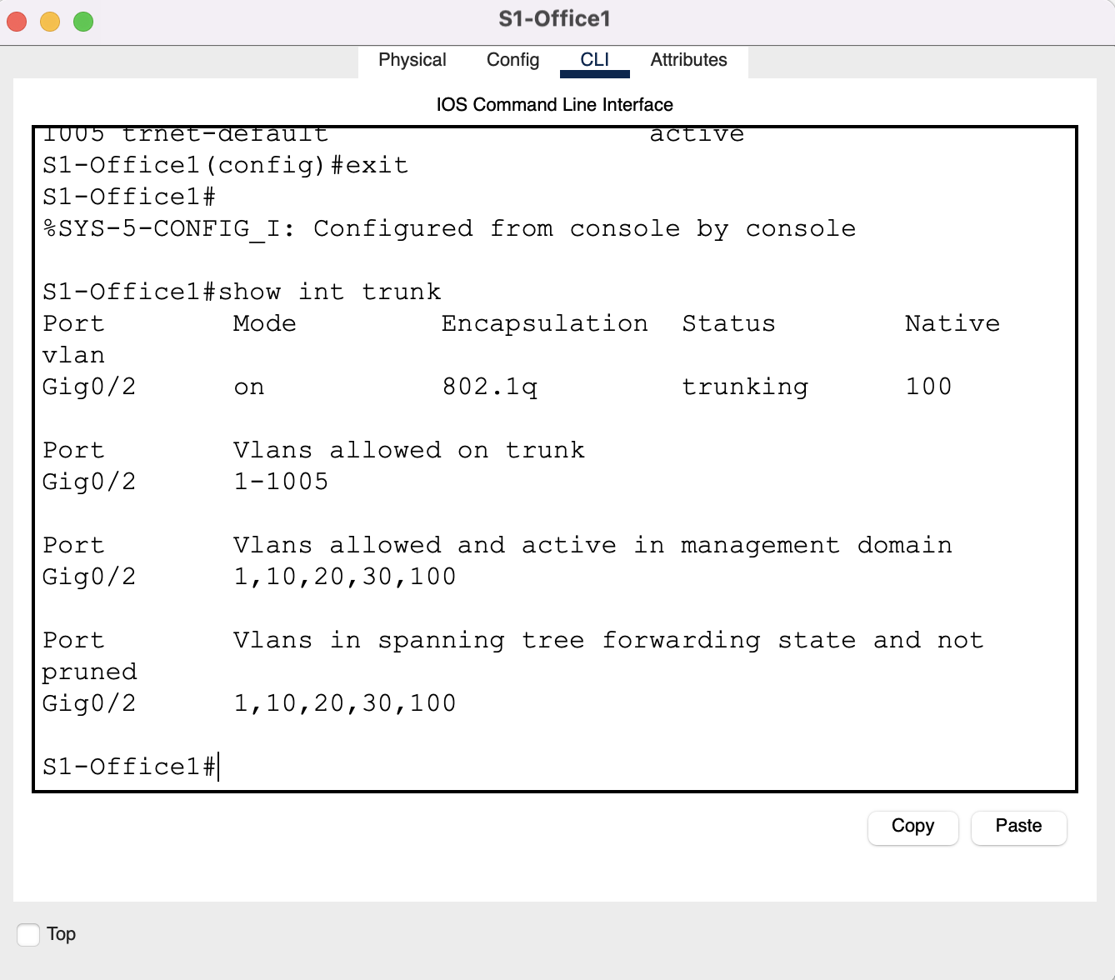

**Lab Task 3: Assign IP Addresses**

|  |  |  |  |  |
| --- | --- | --- | --- | --- |
| **Device** | **Interface** | **Address** | **Subnet Mask** | **Default Gateway** |
| **R1** | Gig0/0/0 | --- | 255.255.224.0 | --- |
|  | Serial0/1/0 | 172.16.128.1 | 255.255.224.0 | --- |
|  | Serial0/1/1 | 172.16.160.1 | 255.255.224.0 | --- |
|  | Gig0/0/0.10 | 172.16.0.1 | 255.255.224.0 | --- |
|  | Gig0/0/0.20 | 172.16.32.1 | 255.255.224.0 | --- |
|  | Gig0/0/0.30 | 172.16.64.1 | 255.255.224.0 | --- |
| **R2-Edge_router** | Serial0/1/0 | 172.16.96.2 | 255.255.224.0 | --- |
|  | Serial0/1/1 | 172.16.160.2 | 255.255.224.0 | --- |
| **R3** | Gig0/0/0 | 172.16.192.1 | 255.255.224.0 | --- |
|  | Serial0/1/0 | 172.16.128.2 | 255.255.224.0 | --- |
|  | Serial0/1/1 | 172.16.96.1 | 255.255.224.0 | --- |
| **S1-Office1** | VLAN 10 (Management) | --- | 255.255.224.0 | 172.16.32.1 |
|  | VLAN 20 (Marketing) | --- | 255.255.224.0 | 172.16.32.1 |
|  | VLAN 30 (Accounting) | --- | 255.255.224.0 | 172.16.32.1 |
| **S2-Office1** | VLAN 10 (Management) | --- | 255.255.224.0 | 172.16.160.1 |
|  | VLAN 20 (Marketing) | --- | 255.255.224.0 | 172.16.160.1 |
|  | VLAN 30 (Accounting) | --- | 255.255.224.0 | 172.16.160.1 |
| **CEO1** | FastEthernet0/0 | 172.16.0.2 | 255.255.224.0 | 172.16.0.1 |
| **CEO2** | FastEthernet0/1 | 172.16.0.3 | 255.255.224.0 | 172.16.0.1 |
| **Dialer1** | FastEthernet0/2 | 172.16.32.2 | 255.255.224.0 | 172.16.32.1 |
| **Dialer2** | FastEthernet0/0 | 172.16.32.3 | 255.255.224.0 | 172.16.32.1 |
| **Copywriter1** | FastEthernet0/1 | 172.16.64.9 | 255.255.224.0 | 172.16.64.1 |
| **Copywriter2** | FastEthernet0/2 | 172.16.64.2 | 255.255.224.0 | 172.16.64.1 |
| **Emp1** | FastEthernet0/0 | 172.16.192.2 | 255.255.224.0 | 172.16.192.1 |
| **Emp2** | FastEthernet0/1 | 172.16.192.3 | 255.255.224.0 | 172.16.192.1 |
| **guest** | FastEthernet0/2 | 172.16.192.4 | 255.255.224.0 | 172.16.192.1 |

**Configure R2:**

* + **Seiral 0/1/0:**

En

Conf t

Interface se0/1/0

Ip address 172.16.96.2 255.255.224.0

No shutdown

Exit

* + **Seiral 0/1/1:**

Interface se0/1/1

Ip address 172.16.160.2 255.255.224.0

No shutdown

Exit

Exit

wr

**Configure R3:**

* + **Seiral 0/1/0:**

En

Conf t

Interface se0/1/0

Ip address 172.16.128.2 255.255.224.0

No shutdown

Exit

* + **Seiral 0/1/1:**

Interface se0/1/1

Ip address 172.16.96.1 255.255.224.0

No shutdown

Exit

* + **Gig 0/0/0:**

Interface gig0/0/0

Ip address 172.16.192.1 255.255.224.0

No shutdown

Exit

Exit

wr

**Configure R1:**

* + **Seiral 0/1/0:**

En

Conf t

Interface se0/1/0

Ip address 172.16.128.1 255.255.224.0

No shutdown

Exit

* + **Seiral 0/1/1:**

Interface se0/1/1

Ip address 172.16.160.1 255.255.224.0

No shutdown

Exit

* + **Gig 0/0/0:**

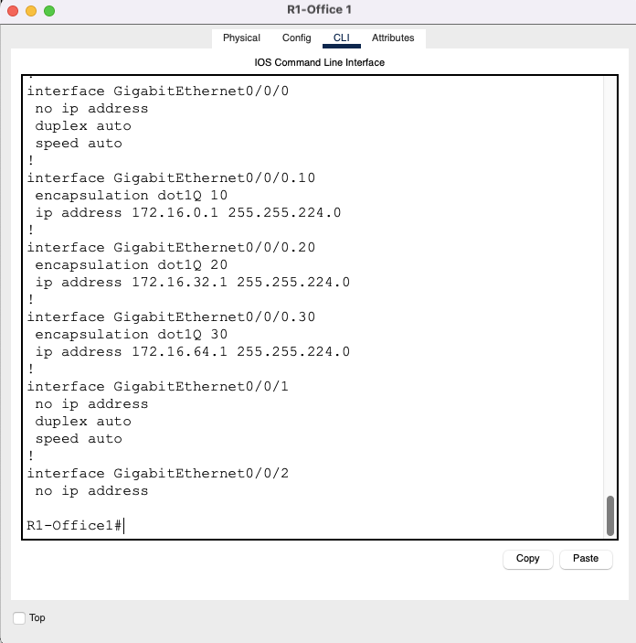Interface gig0/0/0

No shutdown

Exit

**Lab Task 4: Configure R1 for Inter-VLAN Routing***(Listed commands were executed on R1, unless otherwise stated.)*

* + **Gig0/0/0.10**

int g0/0/0.10

encapsulation dot1q 10

ip add 172.16.0.1 255.255.224.0

exit

* + **Gig0/0/0.20**

int g0/0/0.20

encapsulation dot1q 20

ip add 172.16.32.1 255.255.224.0

exit

* + **Gig0/0/0.30**

int g0/0/0.30

encapsulation dot1q 30

ip add 172.16.64.1 255.255.224.0

exit

* + **On S1-Office1 & S2-Office2, set GigabitEthernet 0/1 as Trunk, with appropriate Native VLAN.**

en

conf t

int gig0/1

switchport mode trunk

switchport trunk native vlan 100

no shutdown

exit

**Lab Task 5: Static Routing for network devices**

* + **R3-Office 2:**

En

Conf t

ip route 172.16.0.0 255.255.224.0 172.16.128.1

ip route 172.16.32.0 255.255.224.0 172.16.128.1

ip route 172.16.64.0 255.255.224.0 172.16.128.1

ip route 172.16.96.0 255.255.224.0 172.16.96.2

ip route 172.16.160.0 255.255.224.0 172.16.96.2

exit

wr

* + **R2-Edge_router:**

En

Conf t

ip route 172.16.0.0 255.255.224.0 172.16.160.1

ip route 172.16.32.0 255.255.224.0 172.16.160.1

ip route 172.16.64.0 255.255.224.0 172.16.160.1

ip route 172.16.128.0 255.255.224.0 172.16.96.1

ip route 172.16.192.0 255.255.224.0 172.16.96.1

exit

wr

* + **R1-Office 1:**

en

conf t

ip route 172.16.96.0 255.255.224.0 172.16.96.2

ip route 172.16.192.0 255.255.224.0 172.16.128.2

ip route 0.0.0.0 0.0.0.0 172.16.160.2

exit

**Lab Task 6: Initial and Security Settings for Network Devices**  
*(Listed commands were executed on all routers and switches)*

1. en  
   conf t  
   username Admin password ACDC1973
2. line console 0  
   login local  
   exit
3. enable password beatles1960
4. service password-encryption
5. banner motd #ONLY for admin’s#  
   ex  
   wr  
   ex

**Lab Task 7: Secure Remote Access***(Listed commands were executed on R1, R2, and R3)*

1. ip domain-name aast.com
2. crypto key generate rsa
3. 1024
4. ip ssh version 2
5. line vty 0 4  
   login local  
   transport input ssh  
   exit
6. ex  
   sho ip ssh  
   sho run  
   wr

1. Using the command ssh -l Admin *IP-Address*, I was able to successfully SSH into the routers.

